**UNIVERSIDAD TECNOLÓGICA DE TIJUANA**

**TECNOLOGÍAS DE LA INFORMACIÓN**

**ÁREA DESARROLLO DE SOFTWARE MULTIPLATAFORMA**

MATERIA:

**SISTEMAS OPERATIVOS**

PROFESOR:

**HUMBERTO VEJAR**

ESTUDIANTE:

**Gonzalez Gonzalez Brandon**

GRUPO:

**3D BIS**

UNIDAD:

**III. COMANDOS BÁSICOS DE SOSTEMAS OPERATIVOS BASADOS EN UNIX.**

TEMA:

**GESTIÓN DE ARCHIVOS Y DIRECTORIOS.**

ACTIVIDAD:

* **DESCRIBIR EL PROCESO DE CREACIÓN, MODIFICACIÓN Y ELIMINACIÓN DE ARCHIVOS Y DIRECTORIOS, ASÍ COMO SUS PERMISOS.**
* **REALIZAR DE CREACIÓN, MODIFICACIÓN Y ELIMINACIÓN DE ARCHIVOS Y DIRECTORIOS, ASÍ COMO SUS PERMISOS.**

FECHA:

**31 DE OCTUBRE DE 2024**

**NDG LINUX ESSENTIALS**

**Log File Archiving Challenge**

This challenge lab is designed as an extension of the course, to be used for instructor-led training. Instructors may distribute this lab to students as a supplemental assignment.

# Case Scenario

There has been suspicious activity on the system. In order to preserve log information, it will be necessary to archive the current files in **/var/log** ending with the ".log" extension. The files are to be saved to a file named **log.tar**, stored in the directory, **~/archive**.

It has also been requested that the files that were archived be saved to a directory, **~/backup**.

# Objectives

* Create an archive named **log.tar** that is stored in the archive directory located in the home directory.
* Produce verbose output while archiving.
* List the contents of the archive without extracting. •
* Extract the files to the directory, ~/backup.

# Curriculum Resources

* Module 5 - Getting Help
* Module 6 - Working with Files and Directories
* Module 7 - Archiving and Compression

# Deliverables

* Provide the final commands for successful completion.
* Provide screen captures of the commands required to complete the tasks.
* The final result of the archive listing should match the following:

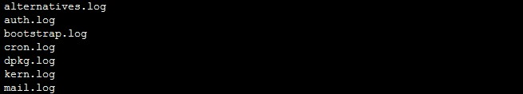

* The final result of the listing of the backup directory should match the following:

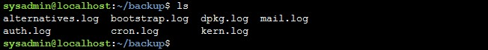

**Note:** Write your commands in plain text, instead of images you can use snipped images to show your command results and output.

**brandon-gonzalez@dell-Inspiron-5547:~$** mkdir -p ~/archive

**brandon-gonzalez@dell-Inspiron-5547:~$** mkdir -p ~/backup

**brandon-gonzalez@dell-Inspiron-5547:~$** cd /var/log

**brandon-gonzalez@dell-Inspiron-5547/var/log$** sudo tar cvf ~/archive/log.tar *.log

**brandon-gonzalez@dell-Inspiron-5547/var/log$** tar tf ~/archive/log.tar

**brandon-gonzalez@dell-Inspiron-5547:~$** cd ~/backup

**brandon-gonzalez@dell-Inspiron-5547:~/backup$** tar xvf ~/archive/log.tar



